**Applied Industrial Internet of Things**

Configuration of Address Resolution Protocol (ARP)

**Construct simple LAN and understand the concept and operation of Address Resolution Protocol (ARP).**

Problem Description:

Construct simple LAN and understand the concept and operation of Address Resolution Protocol (ARP) using Cisco Packet Tracer. Utilize PCs, 8 port switch and LAN cable.

* Aim:

Construct simple LAN and understand the concept and operation of Address Resolution Protocol (ARP) using Cisco Packet Tracer.

* Problem statement:

Construct simple LAN and understand the concept and operation of Address Resolution Protocol (ARP) using Cisco Packet Tracer. Utilize PCs, 8 port switch and LAN Cable.

* Required components to develop solutions:

1. Personal computer
2. Cisco Packet Tracer
3. PCs
4. 8 Port Switch
5. LAN Cable

* Simulated Circuit:

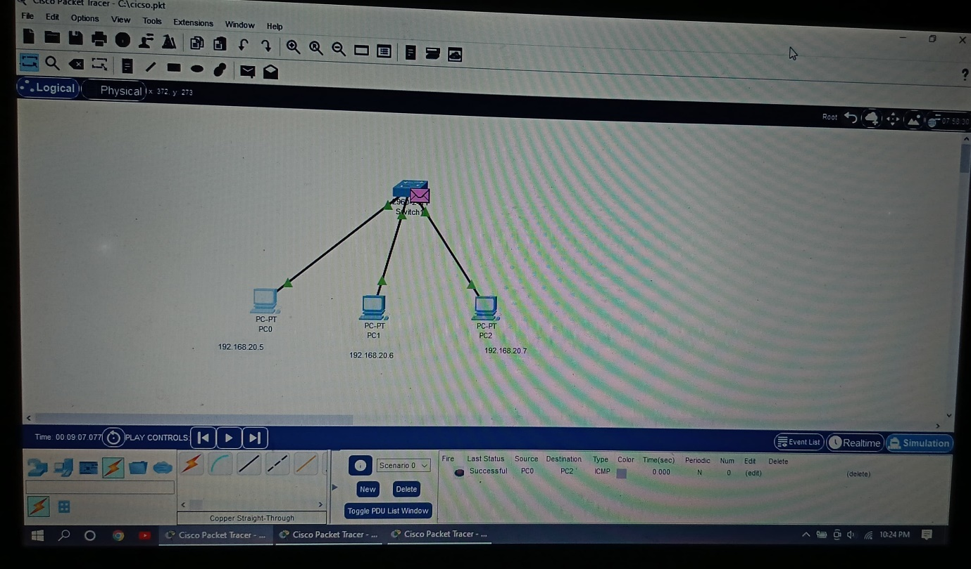

* Scope of the solution:

**Step 1: Set Up the Network in Cisco Packet Tracer:**

1. Open Cisco Packet Tracer and create a new project.
2. Add Devices:

* From the devices list, drag and drop three PCs (PC-0 and PC-1 and PC-2) onto the workspace.
* Drag and drop an 8-port switch (e.g., Switch-PT) onto the workspace.

1. Connect Devices:

* Use the Copper Straight-Through cable to connect
* Connect The Network as Shown in The Circuit Diagram

**Step 2: Configure IP Addresses:**

1. Assign IP Addresses to PCs:

* Click on PC-0, go to the Desktop tab, and select IP Configuration.
* Assign the IP address 192.168.20.5 and the subnet mask 255.255.255.0.
* Close the configuration window.
* Repeat the process for PC-1, assigning the IP address 192.168.20.6 and the subnet mask 255.255.255.0.
* Repeat the process for PC-2, assigning the IP address 192.168.20.7 and the subnet mask 255.255.255.0.
* Configure the IP Address to the All PCs as show in the figure

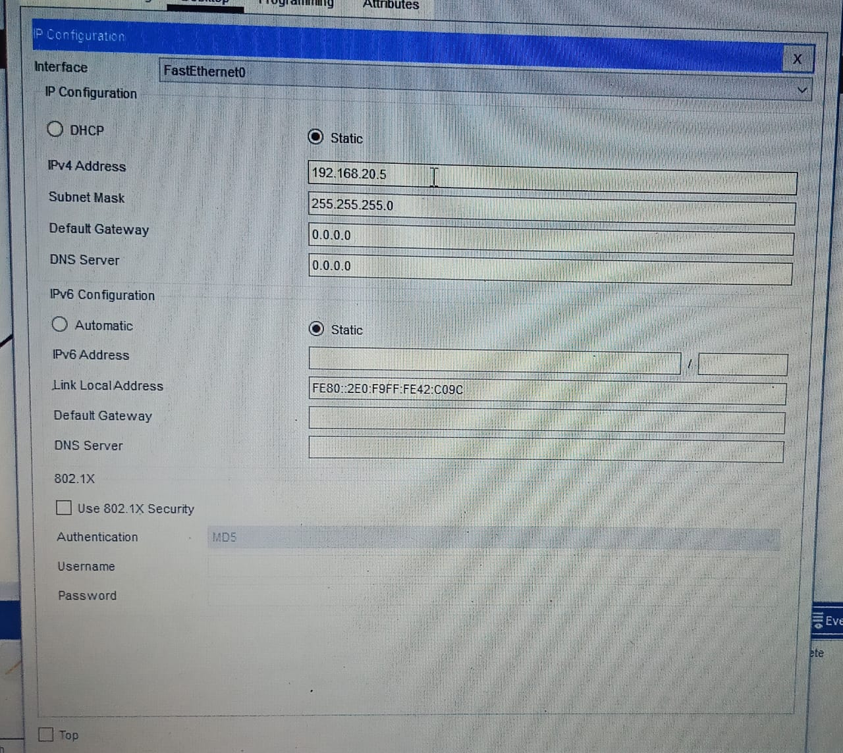

**Step 3: Test Connectivity:**

1. Ping Test:

* Click on PC-0, go to the Desktop tab, and select Command Prompt.
* Type the command ping 192.168.20.6 and press Enter.
* You should see replies from 192.168.20.6, indicating successful connectivity.
* Type the command ping 192.168.20.7 and press Enter.
* You should see replies from 192.168.20.7, indicating successful connectivity.
* From this pining of the PC-0 complete
* Follow the same steps for the remaining PCs i.e PC-1 and PC-2.

**Step 4: Understand ARP Operation:**

1. Clear ARP Cache:

* On PC-0, in the Command Prompt, type arp -d to clear the ARP cache.
* On PC-1, do the same by opening the Command Prompt and typing arp -d.

1. Generate ARP Request:

* On PC-0, in the Command Prompt, type ping 192.168.1.11 again.
* This action generates an ARP request to find the MAC address of PC-1.

1. View ARP Table:

* On PC-0, in the Command Prompt, type arp -a to view the ARP table.
* You should see the IP address 192.168.1.11 mapped to its corresponding MAC address.

**Step 5: Analyze ARP Packets:**

1. Capture and Analyze Packets:

* In Cisco Packet Tracer, use the simulation mode to capture and analyze packets.
* Click on the Simulation tab at the bottom.
* Generate traffic by pinging from PC-0 to PC-1.
* Pause the simulation and examine the captured packets.
* Look for ARP requests and replies to understand how ARP resolves IP addresses to MAC addresses.

**Summary**

* LAN Setup: Two PCs connected to an 8-port switch.
* IP Configuration: PCs assigned IP addresses in the same subnet.
* Connectivity Test: Using the ping command to verify communication.
* ARP Operation: Clearing the ARP cache, generating ARP requests, and viewing the ARP table.
* Packet Analysis: Using simulation mode to capture and examine ARP packets.

**Ping test diagram:**

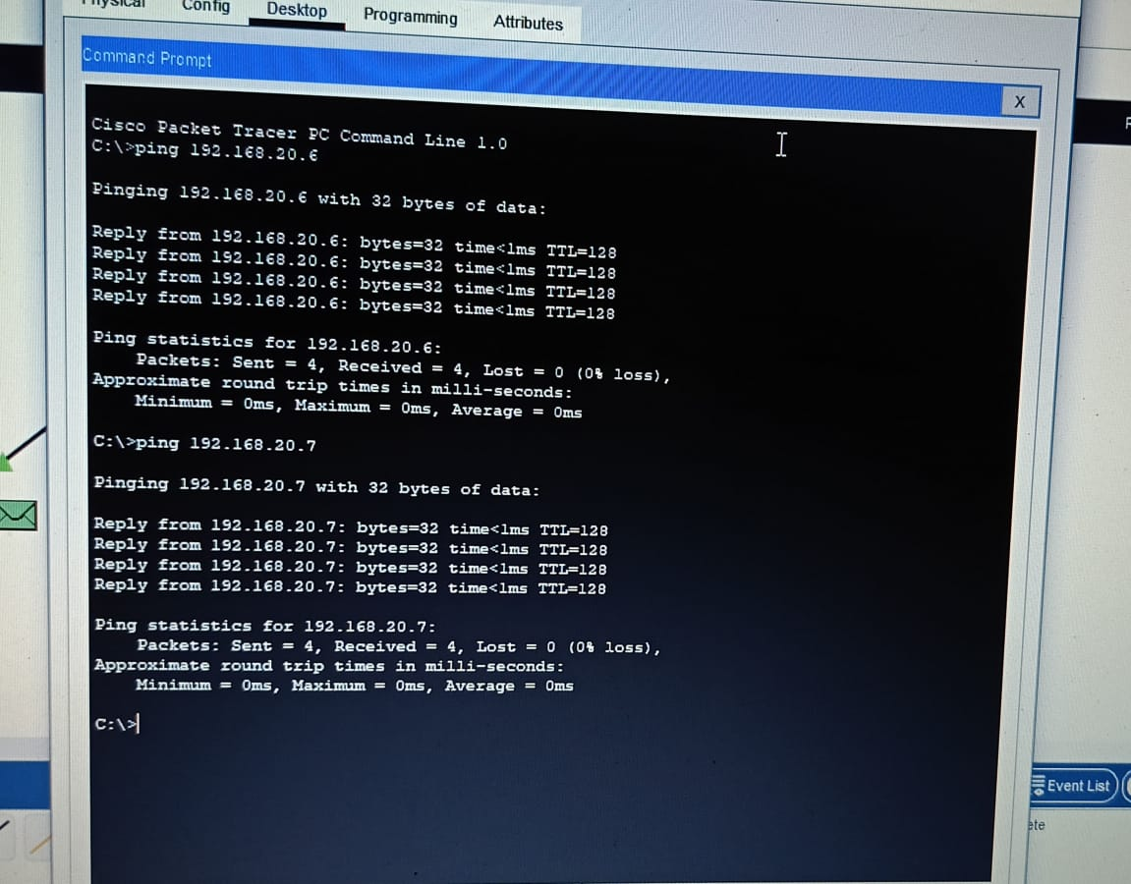

By following these steps, you can set up a simple LAN and gain a practical understanding of how ARP operates within a network using Cisco Packet Tracer.